Learning goals: Students will be able to accurately interpret and draw position, velocity and acceleration graphs for common situations and explain their reasoning.

1. Investigate Moving Man by having the man move using the sliders. Use the playback features to look at the graphs. While you make observations talk about the reasons the graphs look the way they do.

2. Make a chart like the one below on your own paper. Without using Moving Man, sketch what you think the graphs would look like for the following scenario and explain your reasoning.

Scenario: The man starts at the tree and moves toward the house with constant velocity
Position - time graph | Explain your reasoning for the graph’s appearance
Velocity - time graph | Explain your reasoning for the graph’s appearance
Acceleration - time graph | Explain your reasoning for the graph’s appearance
3. Now, use the Moving man simulation to verify or correct your predicted graphs and reasoning with a different color pen.

4. Make new charts for each of the following scenarios. Predict what you think the graphs will look like, and then use Moving man to verify or correct your predicted graphs and reasoning with a different color pen.

a. The man starts three meters from the house and accelerates towards the tree.
b. The man stands still while he talks on his cell phone at the middle of the sidewalk, then walks toward the house at a constant rate trying to get better cell reception. He comes to a sudden stop when the coverage is good (about a meter before the house) and stands still to finish his conversation.
c. The man starts close to the house, stands still for a little while, then walks toward the tree at a constant rate for a while, then the slows to a stop.

Scenario: a
Position - time graph | Explain your reasoning for the graph’s appearance
Velocity - time graph | Explain your reasoning for the graph’s appearance
Acceleration - time graph | Explain your reasoning for the graph’s appearance

Scenario: b
Position - time graph | Explain your reasoning for the graph’s appearance
Velocity - time graph | Explain your reasoning for the graph’s appearance
Acceleration - time graph | Explain your reasoning for the graph’s appearance

Scenario: c
Position - time graph | Explain your reasoning for the graph’s appearance
Velocity - time graph | Explain your reasoning for the graph’s appearance
Acceleration - time graph | Explain your reasoning for the graph’s appearance

5. Look at your graphs, reasonings and the corrections from questions 2 and 3. Talk about why some of your predictions were wrong and how your ideas about motion have changed.

6. Sketch the position, velocity and acceleration graphs for the following scenario:

A man wakes up from his nap under the tree and speeds up toward the house. He stops because he is worried that he dropped his keys. He stands still as he searches his pockets for his keys. Once he finds them, he continues calmly to walk toward the house and then slows to a stop as he nears the door.

Scenario: Question 6
Position - time graph | Explain your reasoning for the graph’s appearance
Velocity - time graph | Explain your reasoning for the graph’s appearance
Acceleration - time graph | Explain your reasoning for the graph’s appearance

7. Individually write a possible scenario for the following graph. Then compare your scenario with your lab partners to check if its reasonable. 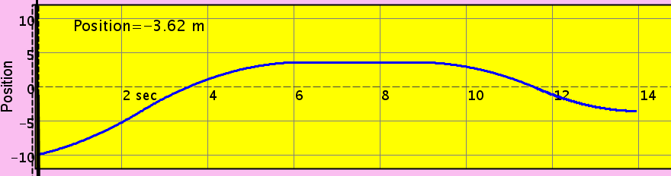 time

- Below is a graph of a ball’s motion. Which of the following gives the best interpretation of the ball’s motion?
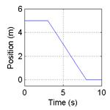
- The ball moves along a flat surface. Then it moves forward down a hill, and then finally stops.
- The ball doesn’t move at first. Then it moves forward down a hill and finally stops.
- The ball is moving at constant velocity. Then it slows down and stops.
- The ball doesn’t move at first. Then it moves backwards and then finally stops.
- The ball moves along a flat area, moves backwards down a hill and then it keeps moving.

- Which graph would best depict the following scenario? A man starts at the origin, walks back slowly and steadily for 6 seconds. Then he stands still for 6 seconds, then walks forward steadily about twice as fast for 6 seconds. Note that these are velocity-time graphs.

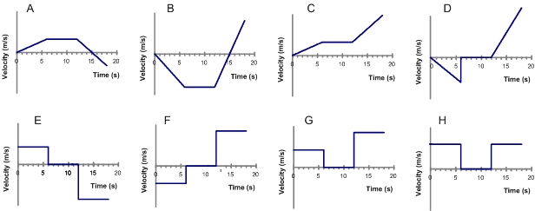
- For the same scenario as # 2, which position-time graph best depicts the motion?
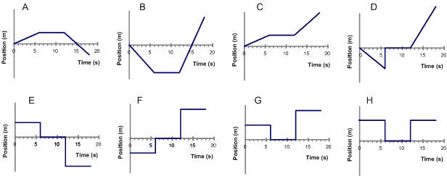

- A car is traveling along a road. Its velocity is recorded as a function of time and is shown in the graph below.
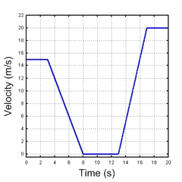
During which intervals is the car accelerating? Choose all the answers that apply.
  - between 0 and 3 seconds
  - for a brief instant at 3,8,13 and 17 seconds
  - between 3 and 8 seconds
  - between 8 and 13 seconds
  - between 13 and 17 seconds
  - between 17 and 20 seconds

5. Which of the following position-time graphs would be consistent with the motion of the car in question #4?
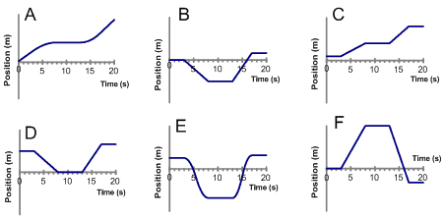

6. A car is moving forward and applying the break. Which position-time graph best depicts this motion?
